INTEGRATION OF BIOREFINERY CLUSTERS TOWARDS ZERO EMISSIONS

Janis Gravitis¹, Janis Abolins², Arnis Kokorevics¹

¹Laboratory of Biomass Eco-Efficient Conversion of the Latvian State Institute of Wood Chemistry, 27 Dzerbenes Street, Riga, LV-1006, Latvia
²Institute of Atomic Physics and Spectroscopy of the University of Latvia, Riga, LV-1586, Latvia

Abstract

Depletion of world recourses, increasing pollution, and climate change make us shift from linear economy to system economy – an economy of technologies integrated to reach a non-polluting zero emissions production system. Transition to renewable resources requires replacement the present crude oil refinery by biomass refinery. Along with conventional biomass refinery technologies bioengineering and nano-technologies become significant players of systems in the design of clusters of integrated biorefinery technologies. The authors consider a number of case-studies of biomass conversion into value-added chemicals and sources of energy, the steam explosion autohydrolysis (SEA) in particular. Modelling of the SEA processes is represented by a preliminary analysis of energy flows. The eMergy (energy memory) approach is applied to assess environmental impacts and sustainability.

Keywords: biomass, biorefinery, systems design, zero emissions

1. Introduction

The UN University/ Institute of Advanced Studies (UNU/IAS) Zero Emissions concept (Gravitis, 1999; Gravitis and Della Senta, 2001; Gravitis et al., 2004; Gravitis, 2007; Pauli, 1998) has the following objectives:
- to emphasizes shift from the traditional linear industrial model in which wastes are considered the norm, to integrated technologies systems utilizing everything;
- to introduce sustainable cycles as found in nature;
- to prescribe reorganization of industries into clusters the wastes of one complying with input requirements of another and the integrated whole producing no waste of any kind.
Zero emission means shift from “cradle to grave” (LCA) to “cradle to cradle”.
Biorefinery, according to the Laboratory of Biomass Eco-Efficient Conversion of the Latvian State Institute of Wood Chemistry (LSIWC/LBE-EC) (Gravitis et al., 1997; Gravitis, 2006; Gravitis, 2008), is a cluster of integrated technologies converting biomass into transportation fuels, power, chemicals, and advanced materials within the zero emissions framework and comprises two platforms: Energy and Chemicals & materials (Fig.1).

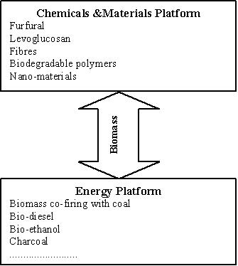

Fig. 1. Platforms of the LSIWC/LBE-EC biorefinery concept

The biorefinery concept is an analogue of today's petroleum refineries producing multiple fuels and products from petroleum. By combining chemistry, biotechnology, engineering and systems approach, biorefineries could produce food, feed, fertilizers, industrial chemicals, fuels, and power from biomass. Many of the biorefinery ideas overlap with the ideas and approaches of green chemistry (Gravitis, 2006).
As highlighted by Kamm and Kamm (2004), „…biorefineries combine the necessary technologies between biological raw materials and industrial intermediates and final products. The principal goal in the development of biorefineries is defined as (biomass) feedstock-mix + process-mix = product-mix”.
Advancement of up-to-date and efficient technological implementations of biomass conversion becomes particularly vital as the deposits of non-renewable resources are being used up (Fig. 2) the products of photosynthesis becoming the only available source of organic fuels and chemicals. Under conditions of severe competition for the carriers of captured solar energy limited by the terrestrial annual total of 56 Gt fixed carbon (Potter, 1999) efficient and sustainable consumption of the unique resource is extremely important for the future bio-refineries required to replace the present petrochemical factories.

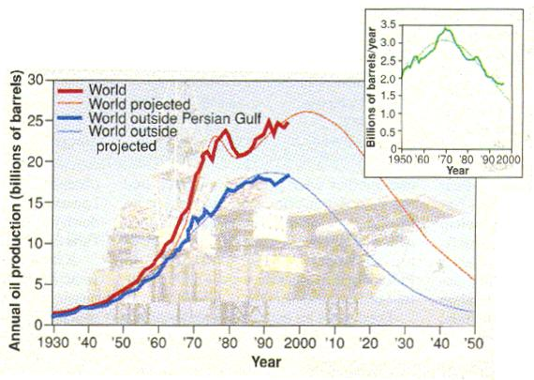

Fig. 2. Predicted peaks in the world oil production
(Right top - Hubbert King predicted oil peak in the U.S. upper states (Kerr, 1998))

2. Case studies

2. 1. Steam explosion pre-treatment. First, second, and third generation feedstock for bio-fuels

The main idea of Zero Emission is zero wastes and clustering of industries. Steam explosion auto-hydrolysis (SEA) can serve as a seed for dispersed but integrated clusters comprising fine chemical industry, paper industry, building industry, food industry, pharmaceutical industry, fuel industry, biotechnology, and farming.
Efficient pre-treatment technologies and new uses of lignocellulosic biomass are needed for future bio-refineries. SEA being one of the most prospective pre-treatment technologies facilitates separation of the lignocellulosic biomass components in a single course of action providing the source for biofuels, chemicals, and nano-materials.
SEA (steam explosion, steam explosion pulping, steam cracking) principally is a simple technique (Gravitis, 1987). The biomass is treated with saturated steam at pressures up to 4 MPa. The treatment time varies from some seconds to some minutes.
After being held at high pressure, within a split second, the biomass is decompressed (exploded) to ambient pressure. Empirically result of SEA is determined by severity parameter R_{o} expressed as (Heitz et al., 1991) (Eq. 1):

R_{o} = t * exp [(T- 100)/ 14.75] (1)

where duration of exposure to high pressure (t, minutes) and temperature (T, ºC) express the SEA severity against the base temperature T_{base} = 100 ºC. Similar SEA results may be achieved with different combinations of t and T. However, there is a contribution from other factors such as moisture content of the sample, size of particles etc.
The principal block scheme of SEA is shown in Fig.3.

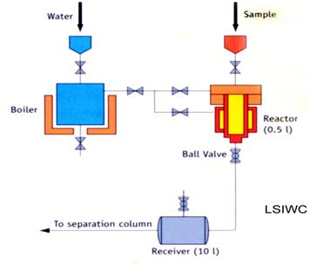

Fig. 3. Steam explosion unit

Of a number of chemical and physical processes occurring during the SEA treatment, two are most important (Table 1).
Since the lignocellulosic material, under conditions of steam explosion, can provide “self-sufficient” chemical and physical transformation (Kokorevics et al., 1999) both the processes, hydrolysis and defibration, can be achieved without any additional reagents (except steam). Further fractionation (Gravitis, 1996) of the biomass products after SEA is rather simple (Fig. 4). The main problem is optimizing fractionation technologies including vacuum evaporation, microfiltration, ultrafiltration, reverse osmosis etc., after the SEA treatment.

Table 1. Processes with special significance during SEA treatment

Process | Description
P1 | - the functional groups are cut off during the process and thereby acid molecules are formed in the system (for example, acetic groups of hemicelluloses form acetic acid)  - these newly formed acids act as catalysts of hydrolysis (auto-hydrolysis)
P2 | after sudden release of the pressure at the end of the SEA process, the difference of pressure in the tissues of the material and surroundings blasts the material providing an effective defibration of wood or other biomass.

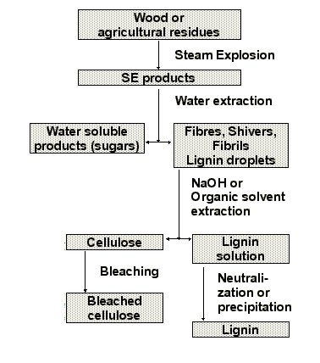

Fig. 4. Fractionation of steam exploded biomass (Gravitis, 1996)

All SEA products have a variety of applications (Gravitis, 1996). Hemicelluloses (Fig. 5), during the SEA can be hydrolysed to sugars – xylose, mannose, arabinose, etc. and used as molasses, the substrate for fodder yeast or bio-ethanol. The xylose sugar can be hydrogenated to xylitol (sweetener) and can also be dehydrogenated to furfural – an excellent feedstock for chemical processing.
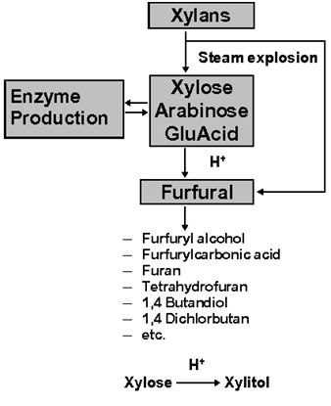

Fig. 5. SEA treatment products from hemicelluloses (Gravitis, 1996)

Lignin can be used as binder to plywood, fibreboards and particle boards (Fig. 6). Lignin is also used as a component in coatings and foams. Lignin and its modification serve as dispersants, slow-release fertilizers, sorbents, carbon fibres, insecticides, and plant hormones. Commercial potential of many lignin derivatives showing good properties is still unclear. Lignin obtained by conventional technologies containing sulphur is often burned and used as a heat source. The SEA lignin is sulphur-free and chemically reactive. During the SEA treatment lignin coalescing in spheres of diameter to some micrometers on the surface of cellulose fibres promotes enzymatic attack on cellulose.

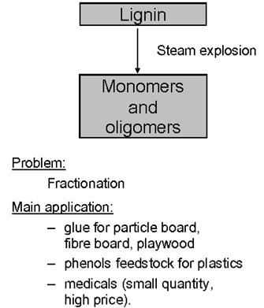

Fig. 6. Application of lignin from SEA pulp (Gravitis, 1996)

Cellulose can be hydrolyzed to glucose and oligosugars (Fig. 7). The enzymatic isomerization of glucose to fructose is well established. Glucose can be fermented to acids, alcohols, polyols and ketones. Derivatives of cellulose serve as animal fodder, substrate for microorganisms and mushrooms, super-high swollen gels, liquid crystals etc. Microcrystalline cellulose is used in paper industry and in food and pharmaceutical industries. The SEA produces cellulose micro-fibrils. It looks perspective to use homogeneously dispersed cellulose fibrils in a polymer matrix of nano-composite structures (nano-technology). Finally, cellulose fibres are a fundamental resource for paper industry.
In addition, the SEA technology is flexible in the meaning of satisfying the demand of tree-free pulping (“tree-free paper”). Extensive deforestation requires that fibre materials are not produced from wood but from sugar cane bagasse, bamboo, straw, kenaf and others.
Rudolf Diesel and Henry Ford were the first to demonstrate the use of bio-fuels from a variety of crops. Now only biodiesel and bio-ethanol are industrial products. However, the feedstock for bio-fuel is food crops the products being called first-generation bio-fuels. The main criticism against first generation bio-fuels is the use of arable land, driving up food prices, and small effect on reducing emissions of greenhouse gases (GHG) (“food versus fuel” controversy).
The challenge is to shift from first generation bio-fuels to second generation bio-fuels the feedstock of which is non-food lignocellulosic materials (straw, wood waste etc.). The main problem of deriving bio-ethanol from cellulose and hemicelluloses is separating lignin from lignocellulosic carbohydrate polymers, and SEA is an excellent method important for material science and energy.

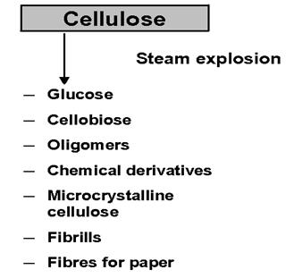

Fig. 7. SEA treated cellulose products and application (Gravitis, 1996)

The most recent is the idea of third-generation bio-fuels. According to Carere et al. (2008) “consolidated bio processing (CBP) is a system in which cellulose production, substrate hydrolysis, and fermentation are accomplished in a single-step process by cellulolytic microorganisms. CBP offers potential for reducing production costs of bio-fuel due to a simpler feedstock processing, lower energy inputs, and higher conversion efficiencies than separate processes of hydrolysis and fermentation, and is an economically attractive near-term goal for “third-generation” bio-fuel production”. Separation of lignin and pre-treatment by the SEA technology will be essential also in case of introducing the process of third-generation bio-fuels.

2.2. Steam explosion energy evaluation

Presently a simple model (Fig. 8) of the main energy flow has been used to assess the energy costs and environmental impacts (Abolins and Gravitis, 2007; Gravitis and Abolins, 2007). The energy consumed in the process depends on the moisture content in the raw material. A critical moisture amount H_{c} beyond which heating of the moisture requires more energy than heating the waterless part of biomass to the operation temperature could be defined by the ratio (Eq. 2):

H_{c} = C_{b} ΔT/ (C_{b} ΔT + Δh) (2)

where:
C_{b} is specific heat of dry biomass;
ΔT – the difference between the operation temperature and the initial temperature;
Δh – difference between the enthalpy of water and steam.
Sustainability of the SEA technology may be considered in two aspects: environmental impacts of a technology on the global system (particularly the biosphere) and physical sustainability of the technological process itself mainly dependent on availability of the necessary resources.
The eMergy (energy memory) approach offered by Odum (1996) based on the energy of solar radiation as the primary source of all other resources and products providing a general basis common for environment, resources, and other components has been applied to estimate the SEA pre-treatment technology (Abolins and Gravitis, 2007). For the model calculations including the basic energy flow and the source material are made under assumptions of sustainable consumption of naturally grown wood, 20% of energy being supplied by hydroelectric power plants and 80 % – by thermoelectric power plants, and any energy or other costs for simplicity being neglected.

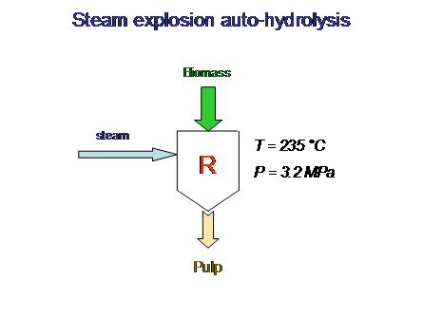

Fig. 8. Model of the steam explosion system (R – reactor)

Defining sustainability S of the process by the ratio of renewable eMergy R (biomass and hydroelectricity) to the total of renewable and non-renewable (thermoelectricity) eMergy NR (Eq. 3):

S = R / (R + NR) (3)

The value of S being zero if R = 0 means that only non-renewable resources are used and the process is not sustainable. If NR = 0, then S = 1 (or 100 %) indicating condition of a completely sustainable process.
Within the simplified model discussed here S equally refers to the environment and the SEA process itself since the major impact on the environment is due to release of carbon dioxide by thermoelectric power plants.
The SEA process can be made completely self-sufficient providing the necessary energy by burning biomass. Defining the net efficiency F of the process by the ratio of energy necessary per unit bio-mass E₀ to energy E > E₀ actually spent per unit mass (Eq. 4):

F = E₀ / E (4)

The latter from (4) may be expressed as (Eq. 5):

E = E₀ / F (5)

If E_{c} is combustion heat of the biomass used to provide the energy for SEA treatment, the ratio E_{c}/E is the number N of biomass units that can be processed at the expense of burning one biomass unit. From equation (5) it may be expressed as (Eq. 6):

N = E_{c} / E = E_{c}∙F / E₀ = F / (E₀ / E_{c}). (6)

Eq. (6) does not specify the kind of biomass used to supply the energy. It is valid under condition that E₀ refers to the biomass undergoing the treatment while E_{c} – to the biomass used to fuel the process. If the same kind of biomass is used as fuel, the E / E_{c} ratio determines the amount of biomass available for treatment or the yield (Eq. 7):

Y = 1/ (1 + E / E_{c}) (7)

2.3. Wood cell wall structure – the opportunity to obtain nano-materials by steam explosion

Nanotechnology as the study of wood cell structures with dimensions of 1-100 nm or larger (microstructures) is a promising field of research and industrial application. Cellulose consists of microscopic fibril nanostructures (whiskers) of high stiffness and strength. The nanostructures of lignin are less clear.
Relationship between structure, function, and properties is the key issue of developing new materials. Recently the shape of lignin particles lacking some exact molecular formula has been determined by ultra-small angle synchrotron X-ray scattering (USAXS).
The TEM, SAXS and USAXS experiments have revealed size-dependent properties of nano-particles obtained by SEA from new cell wall modifications (Kokorevics et al., 1999).
Studies of nano-cell structure and dynamics of natural plant walls would reveal diverse opportunities for natural nano-composites and nano-technologies of synthetic intermediates and substrates to imitate the nature by chemical processes (Gravitis, 2006).

2.4. Design of integrated technology clusters

System design is the first step integrating technologies. Clustered technologies should have maximum throughput and minimum waste. The unsolved problem of Zero Emissions is connecting technologies in an optimized network. Fig. 9 shows the general strategy of integrating technologies (Gravitis, 2003) designed by the LSIWC/LBE-EC. Substituting the primary furfural production by other technologies is not a problem. It depends on the purpose of the integrated cluster.

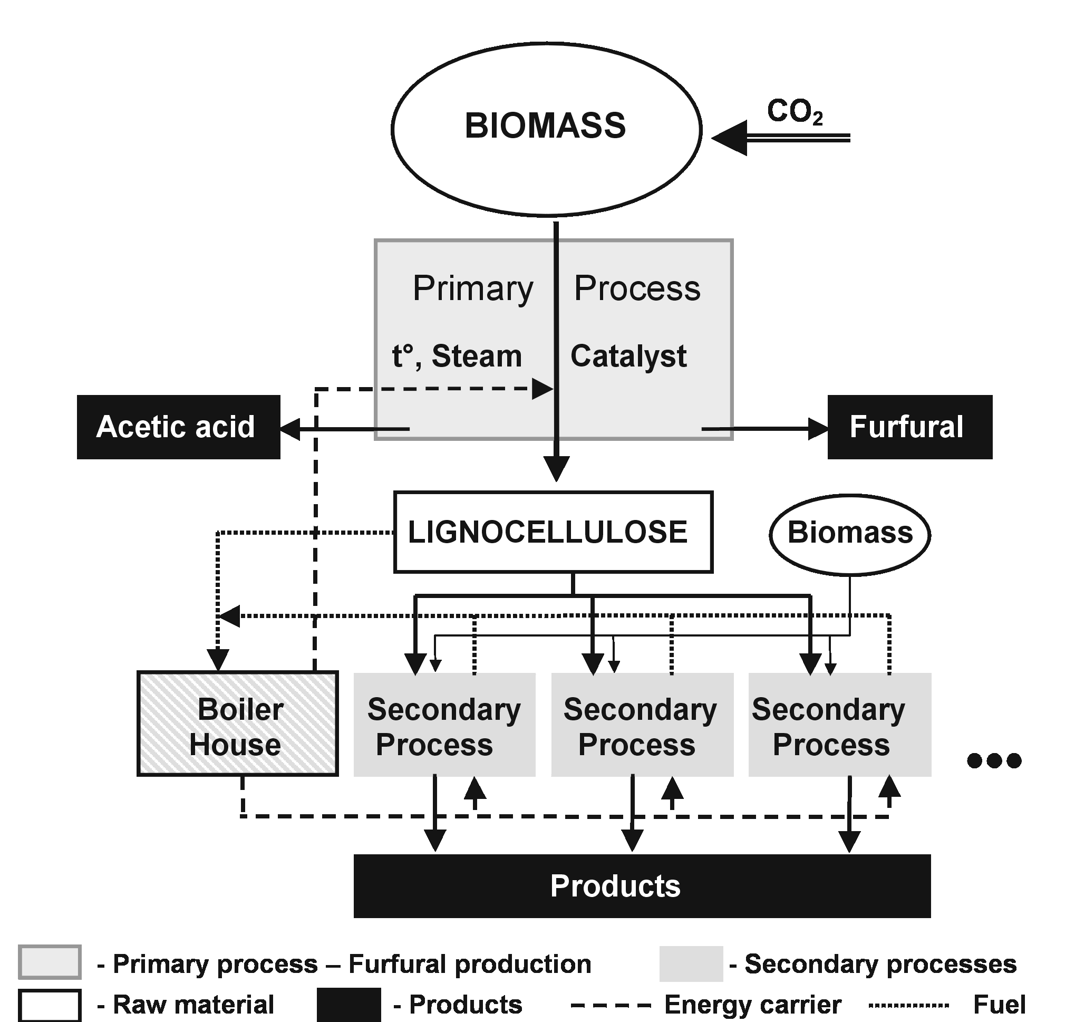

Fig. 9. General design of the flow chart of a LSIWC/LBE-EC biorefineries system (Gravitis, 2003)

3. Results and discussion

3.1. SEA technology for self-binding materials and plywood

Plywood and pressed boards are composites widely used in building constructions and furniture. Developed SEA technologies allow utilizing low-quality and waste-wood to make useful products.
Presently phenols are mainly derived from petrochemicals. The costs of these chemicals depend on the oil price. As the oil price increases, the costs of wood composites raise too – the prices of phenol adhesives correlate with the oil market prices. Another adhesive component – formaldehyde has been classified as human carcinogen in 2004.
Fibre and particle boards are bound together by a suitable synthetic thermosetting adhesive at designed pressure and temperature. Phenol and furan resins synthesized from petroleum materials are expensive, not environmentally benign. The phenol adhesive and exploded self-binding mass after the SEA process (Fig. 10) is cheap. Phenols separated from SEA mass can be used in plywood binders.

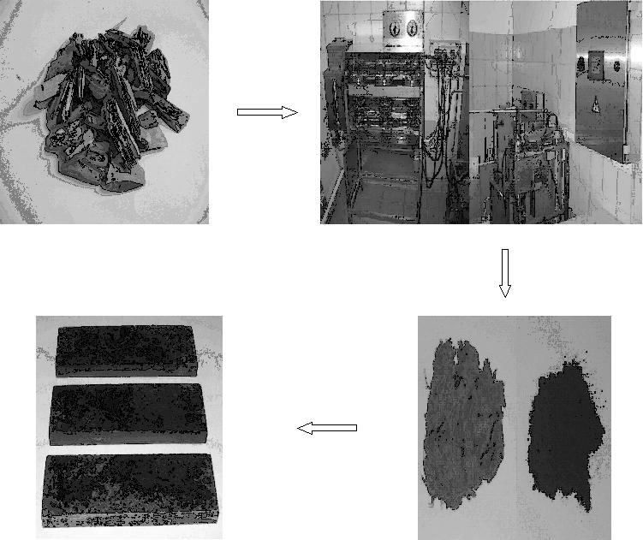

Fig. 10. From wood chips (left) to steam explosion unit, to SEA products, to self-binding boards (right) (Abolins et al., 2008)

An attempt to use lignin extracted from wood biomass after SEA in self-binding boards and plywood has been reported (Abolins et al., 2008; Gravitis et al., 2008) paying attention to economic and energy costs.

3.3. Steam explosion energy evaluation

The critical moisture content defined by Eq. (2) is close to air-dry wood, which means that energy spent on drying biomass should be accounted. There exists some threshold amount of moisture needed to initiate hydrolysis.
Assuming that total energy consumed is 1kWh per kg dry biomass and taking transformations – the solar energy equivalents of hydroelectricity, biomass, and thermoelectricity from M. T. Brown (Brown and Ulgiati, 2004) the value of sustainability index S defined by Eq. (3) is found to be 0.15 approaching 0.1 at 3 kWh/kg and 0.3 at less than 0.5 kWh/kg.
As seen from Eq. (6), the number of processed biomass units N is a linear function of net efficiency F the slope being determined by E₀ / E_{c}. The number of biomass units N that can be processed by SEA per unit biomass combustion energy is shown in Fig. 11.

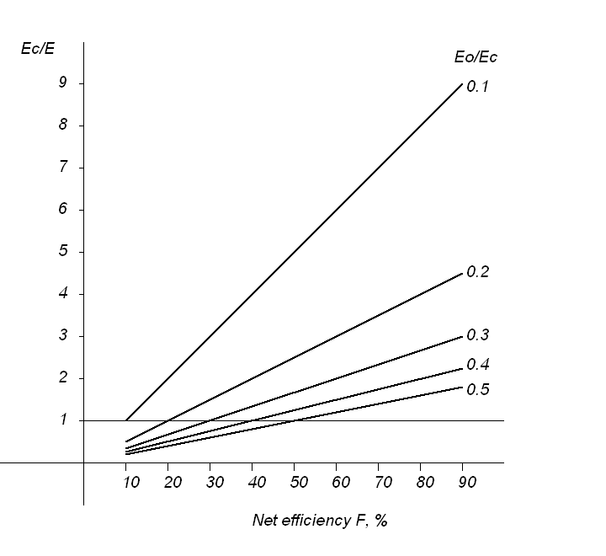

Fig. 11. The ratio of biomass combustion energy E_{c} to net energy E per unit biomass vs. net efficiency F at different pre-treatment energies in terms of E_{c}

The processed biomass yield, Eq. (7), in per cent of the total amount of available biomass as function of net energy per unit mass E in terms of biomass combustion energy E_{c} is shown in Fig. 12. One may regard E = E_{c} as the critical value at which 50% of the available specific biomass resource can be processed by burning the other half. At E > E_{c} more of the available biomass needs to be burned to fuel the treatment. The critical ratio of E_{c} / E = 1 is shown by a line.
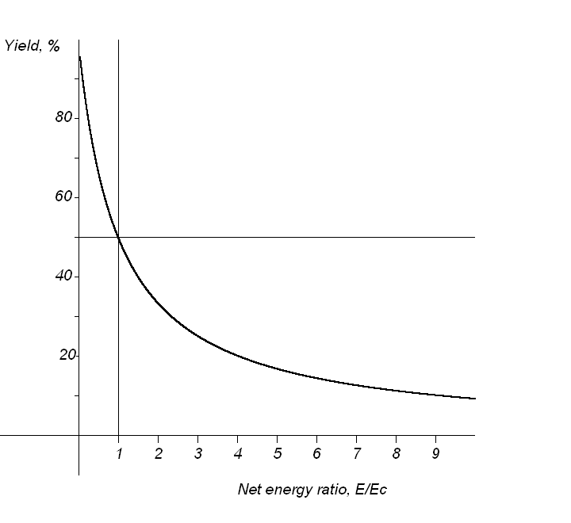
Fig. 12. Amount of biomass available for self-subsistent SEA pre-treatment as function of net energy in terms of biomass combustion energy
3.4. Integration of bio-based technologies in clusters

The mathematical graph on the basis of oriented graph theory used in choosing the optimal routes of raw materials, products, and wastes (Gravitis et al., 2004) is illustrated in Fig. 13.

Fig. 13. Biomass refineries integrated cluster as an oriented mathematical graph
(Gravitis et al., 2004)

Producers should be located close to each other. However, many problems remain unsolved. Apart from output and waste optimization, the profit interests of companies, sometimes controversial to other factors, are significant.
An example (Gravitis et al., 2002) of integrated furfural production technologies, steam explosion, and pyrolysis is given in Fig. 14. The integrated LSIWC/LBEEC systems approach to a biomass technologies cluster is presented in Fig. 15.

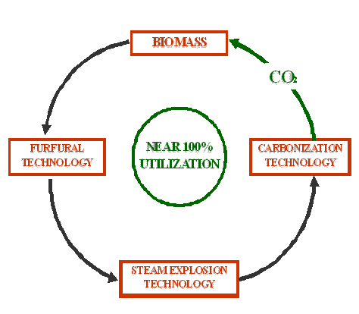

Fig. 14. Integration of three technologies: furfural, steam explosion, and carbonization
(Gravitis et al., 2002)

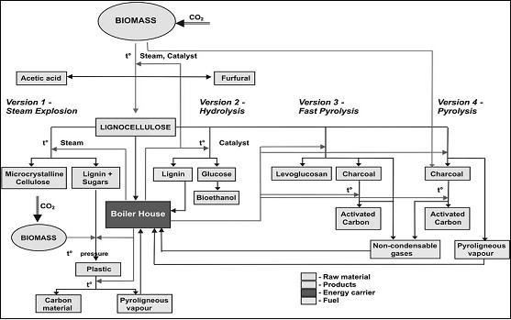

Fig. 15. Biomass based integrated technologies cluster towards Zero Emissions

4. Conclusions

Shift to renewable resources requires replacement the present crude oil refinery by biomass refinery. The future biorefinery technologies will be based on integration in clusters towards zero emissions. The steam explosion autohydrolysis technology renaissance could be point for second and third biofuels resources pre-treatment.

References

Abolins J., Gravitis J., (2007), Biomass conversion to transportation fuels, combustibles, and nano-materials by steam explosion, Latvian Journal of Physics and Technical Sciences, 4, 29-39.
Abolins J., Tupciauskas R., Veveris A., Alksnis B., Gravitis J., (2008), Effects of Steam Exploded Lignin on Environmentally Benign Hot-Pressed Alder Boards, The 7th International Conference on Environmental Engineering, Selected Papers, Vol. 1, Cygas D., Froehner K.D. (Eds.), Vilnius Gediminas Technical University Press Technika, 1-7.
Brown M.T., Ulgiati S., (2004), Encyclopedia of Energy 2, Elsevier, Amsterdam.
Carere C.R., Sparling R., Cicek N., Levin D.B., (2008), Third generation biofuels via direct cellulose fermentation, International Journal of Molecular Sciences, 9, 1342-1360.
Gravitis J., (1987), Theoretical and applied aspects of the steam explosion plant biomass autohydrolysis method, Khimiya Drevesiny (Wood Chemistry), 5, 3-21.
Gravitis J., (1996), Material Separation Technologies and Zero Emissions, Proc. Second Annual UNU World Congress on Zero Emissions, Chattanooga, Tennessee, May 29-31, 168-173.
Gravitis J., Della Senta T., Williams E. D., (1997), The Conversion of Biomass Into Fuels, Fibers and Value Added Chemical Products From The Perspective of The Zero Emissions Concept, Proc. Symp. of the Biomass Conversion, Sapporo, Japan, 1-18.
Gravitis J., (1999), Biorefinery and Lignocelluloses Economy Towards Zero Emissions, In: Biorefinery, Chemical Risk Reduction, Lignocellulosic Economy, Iiyama K., Gravitis J., Sakoda A. (Eds.), ANESC, Tokyo, 2-11.
Gravitis J., Della Senta T., (2001), Global Prospects of Substituting Oil by Biomass, In: World Forests, Markets and Policies III, Palo M., Uusivuori J., Mery G. (Eds.), Kluwer Academic Publ., Dordrect, London, Boston, 23-39.
Gravitis J., Vedernikov N., Zandersons J., Kokorevics A., (2001), Furfural and Levoglucosan Production from Deciduous Wood and Agricultural Wastes, In: Chemicals and Materials from Renewable Resources, Bozell J.J. (Ed.), American Chemical Society, 784, 110-122.
Gravitis J., Andersons J., Vedernikov N., (2002), Chemicals and Materials from Integrated Furfural, Steam Explosion and Pyrolysis Technologies, Proc. 7th European Workshop on Lignocelluloses and Pulp, Turku/Abo, Finland, 503-506.
Gravitis J., (2003), Sustainability Based on Forestry: Economy, Technology and Integrated Cluster Development Problems, Proc. Sustainable Development for the Pulp and Paper Industry, Lisbon, 199-205.
Gravitis J., Zandersons J., Vedernikov N., Kruma I., Ozols-Kalnins V., (2004) Clustering of bio-products technologies for zero emissions and eco-efficiency, Industrial Crops & Products, 20, 169-180.
Gravitis J., (2006), Green Biobased Chemistry Platform for Sustainability, In: Environmental Education, Communication and Sustainability, Vol. 23: Sustainable Development in the Baltic and Beyond, Peter Lang Publishers House, Frankfurt/Maim, Berlin, Bern, Brussels, New York, Oxford, Vienna, 145-160.
Gravitis J., (2007), Zero techniques and systems – ZETS strength and weakness, Journal Cleaner Production, 15, 1190-1197.
Gravitis J., Abolins J., (2007), Biomass Conversion to Chemicals and Nano-Materials By Steam Explosion, 15th European Biomass Conference & Exhibition, 7-11 May, Berlin, Germany.
Gravitis J., (2008), Biorefinery: Biomaterials and Bioenergy from Photosynthesis, Within Zero Emissions Framework, In: Sustainable Energy Production and Consumption. Benefits, Strategies and Environmental Costing. NATO Science for Peace and Security, Barbir F., Ulgiati S., (Eds.), Springer, 327-337.
Gravitis J., Abolins J., Tupciauskas R., Veveris A., Alksnis B., (2008), Lignin from steam-exploded pulp as binder in wood composites with energy account of steam explosion process, Computational Materials Science, in press.
Heitz M., Capek-Ménard E., Koeberle P. G., Gagné J., Chornet E., Overend R. P., Taylor J. D., Yu E., (1991), Fractionation of Populus tremuloides at the pilot plant scale: Optimization of steam pretreatment conditions using the STAKE II technology, Bioresource Technology, 35, 23-32.
Kamm B., Kamm M., (2004), Principles of biorefineries, Applied Microbiology and Biotechnology, 64, 137-145.
Kerr R. A., (1998), The next oil crisis looms large- and perhaps close, Science, 281, 1128-1131.
Kokorevics A., Bikovens O., Gravitis J., (1999), Steam Explosion and Shear Deformation under High Pressure as Methods Providing "self-sufficient" Treatment of Wood and Non-Wood Biomass, Proc. First Workshop on QITS: Materials Life-Cycle and Environmentally Sustainable Development, March 2-4, 1998, Campinas, Sao Paulo, Brazil, Published by the UNU/IAS, Suzuki C., Williams E. (Eds.), 161-165.
Odum H. T., (1996), Environmental Accounting, John Wiley & Sons, New York.
Pauli G., (1998), Upsizing: The Road to Zero Emissions. More Jobs, More Income and no Pollution, Greenleaf, Sheffield.
Potter C. S., (1999), Terrestrial biomass and the effects of deforestation on the global carbon cycle, Bio Science, 49, 769–778.

Sample manuscript, with the permission of authors

Author to whom all correspondence should be addressed: E-mail: jgravit@edi.lv; Phone: +371 67553137; Fax: +371 67550635

